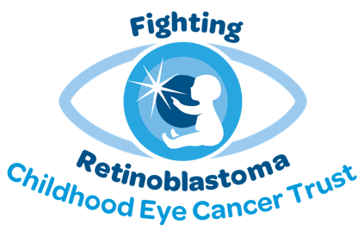

World Retinoblastoma Awareness Week 2025 text

Please help us to raise awareness by sharing our prewritten content on your social media channels during World Retinoblastoma Awareness Week – be sure to tag us on Facebook, Twitter, Instagram, LinkedIn and TikTok and use our hashtag #RbWeek.

To use our images, either right click and save them, screenshot them, or if you are having difficulties – email isabella.greenwood@chect.org.uk who will send them via email. Thank you for your support!

Remember to let us know what you’re up to with the hashtag #RbWeek – we’d love to share it on our social media channels!

Sunday 11th May 2025

Today marks the start of World Retinoblastoma Awareness Week! Would you know the signs and symptoms of retinoblastoma (childhood eye cancer)? Learn more at chect.org.uk #RbWeek

Monday 12th May 2025

If you see a white glow in the eye, a white pupil or white reflection in a photo where a flash has been used, or when your child is in artificial light or a darkish room, visit a GP or optometrist ASAP as this is the most common sign of retinoblastoma (childhood eye cancer) #RbWeek

Tuesday 13th May 2025

A squint, where the eyes do not look in the same direction, can sometimes be a symptom of retinoblastoma. In many cases, it’s nothing more than a squint but all children should be checked out by an optometrist or GP just in case, as it’s the second most common sign of retinoblastoma (childhood eye cancer) #RbWeek

Wednesday 14th May 2025

The iris – the coloured part of the eye – can change colour in one eye, sometimes only in one area, when a child has retinoblastoma (childhood eye cancer). If you notice a change in the colour of your baby or child’s iris, let a GP or optometrist know #RbWeek

Thursday 15th May 2025

Your child’s vision may begin to deteriorate, or they may have had poor vision from birth. You may notice that they don’t focus, fix and follow as well as other children of the same age. You should visit a GP or optometrist and request a fundal (red) reflex test #RbWeek

Friday 16th May 2025

In a photo where one eye has “red eye” (which is normal), the other eye may look black. This can be a sign of retinoblastoma (childhood eye cancer). A fundal (red) reflex test can help to show if further examination is required – so request this test is done by an optometrist or GP #RbWeek

Saturday 17th May 2025

If you spot a sign or symptom of childhood eye cancer (known as retinoblastoma), have your child’s eyes checked out by a GP or optometrist as soon as possible. The most common signs include a white glow in the pupil of the eye or a squint, where the eyes do not look in the same direction. Visit chect.org.uk for more information #RbWeek

Thank you for helping us to spread awareness of retinoblastoma!

