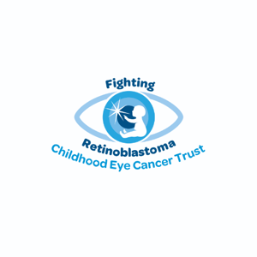

ALT descriptions for images

11th May 2025

The words read 'Do you know the signs of retinoblastoma, a childhood eye cancer?' and the image shows a selection of children and babies with a white glow

12th May 2025

The words read 'A white glow in the eye Can be a sign of eye cancer'. The image shows a boy with a white glow in one eye.

13th May 2025

The image says, 'A squint can be a sign of eye cancer' and it shows a toddler with a squint crawling.

14th May 2025

The words say, ‘A change in iris colour' can be a sign of eye cancer'. It shows a child with two different coloured eyes.

15th May 2025

The words say, 'A deterioration of sight can be a sign of eye cancer' and shows a child with a white glow in one eye.

16th May 2025

The image says, 'One red eye with one black eye in photos can be a sign of eye cancer' and shows a girl with one red eye and one black eye.

17th May 2025

The words read, 'If you spot a sign of retinoblastoma, request a fundal ‘red’ reflex test from your optometrist or GP' and shows a child with a white glow.

