Childhood Eye Cancer Trust (CHECT) Research Grant Final Report (end of grant report)

Please complete all sections of this report and return to petra.maxwell@chect.org.uk.

Project title: | Evaluation of PRELP function using fresh human retinoblastoma samples
Project reference: | 2101Ohnuma2
Total award: | £50,000 (£32,113.27 spent)
Details of any additional funding: | None
Lead investigator: | Prof. Shin-ichi Ohnuma | Administering institution: | UCL
Start date of award: | 02/05/2022 | End date of award: | 20/04/2024

- Final Report
Please structure your report as follows:

  - Summary of findings/results/outcomes of this project (with reference to the aims and objectives stated in your original application).
  - If your aims and objectives changed during the course of the project, please explain why and in what way.
  - Any problems or challenges impacting on the findings / results / outcomes of this project.
  - How will these findings or outcomes impact patients or the public, and in what timescale? Do you foresee any obstacles / barriers to patients benefitting from the research findings?

- Summary of findings/results/outcomes of the project (with reference to the aims and objectives stated in your original application).

This project had the following three aims.
Aim 1: To determine the ability of PRELP to inhibit progression of freshly isolated primary retinoblastoma cells from retinoblastoma patients.
Aim 2: We will determine the mechanism of PRELP action on human retinoblastoma samples.
Aim 3: We will determine correlation between PRELP sensitivity and cellular properties, genetic differences, or clinical outputs.
This funding brought significant progress although we could not perform experiments using freshly isolated retinoblastoma cells.

The RB1 tumor suppressor gene plays a critical role in the development and progression of retinoblastoma, a type of eye cancer. However, the specific processes influenced by RB1 mutations are not fully understood. Our research involving the whole genome sequencing of human retinoblastoma tissues showed that mutations in the RB1 gene are the primary alterations, with few other genetic changes.
We have discovered that the protein PRELP, which is usually abundant in the normal eye's Müller glial cells, is significantly reduced in all cases of human retinoblastoma (1). Our earlier studies indicated that PRELP acts as a tumor suppressor in bladder cancer (2), which suggests that its reduction might play a role in advancing retinoblastoma.
In experiments with mice, removing PRELP led to disorganized eye tissue and increased cell growth. Further tests showed that the absence of PRELP in the retina activates several cancer-related pathways and decreases cell-to-cell adhesion while promoting more aggressive cell behaviors and inflammation.
Conversely, adding PRELP protein to retinoblastoma cell lines improved cell adhesion and inhibited uncontrolled growth, demonstrating that PRELP could potentially help manage or treat retinoblastoma. These findings underscore the importance of PRELP in retinoblastoma and propose its application as a new treatment strategy. This research is also aligned with specific objectives of our grant (3), enhancing our understanding of retinoblastoma's molecular mechanisms.

To further explore the role of PRELP in retinoblastoma, we planned to study fresh human retinoblastoma tissues from patients. We received ethical approval for these studies and began by conducting preliminary experiments on fresh mouse retinal tissue. These initial tests included isolating healthy retinal cells, growing them in culture, and analyzing various cellular properties, such as single-cell mRNA expression. We refined our cell culture techniques by adjusting various parameters to optimize cell health. Unfortunately, despite these preparations, we were unable to obtain fresh human retinoblastoma tissues for our studies. This was largely due to the advances in retinoblastoma treatment, including improved chemotherapy and radiotherapy methods, which have reduced the availability of such tissues.

To further our understanding of PRELP's role in retinoblastoma, we concentrated on two specific aims of our research (Aim-2 and Aim-3). We conducted detailed studies on the molecular function of PRELP in the retina, utilizing mRNA expression profiling and additional cellular biology analyses.
Our research findings reveal that in retinas lacking PRELP, there is significant activation of cellular aging (senescence) (Figure 1) and associated pathways (Table 1), more so than pathways related to cell movement (EMT) and cell adhesion. This was evident from our mRNA profiling comparing normal retinas with those from which PRELP was deleted. We further confirmed the activation of senescence in PRELP-deficient mice through specific staining methods, including Lamin B1 (Figure 2) and SA-β-gal.

Interestingly, when we introduced recombinant PRELP protein to human retinoblastoma cells, our analyses—both at the whole and single-cell levels—showed that PRELP effectively inhibits the pathways leading to senescence (Table 2). Additionally, PRELP regulates several important cellular processes linked to senescence, including mTOR signaling, NF-κB signaling, p53 signaling, cell cycle regulation, and autophagy (Table 1-2).
These findings suggest that PRELP naturally helps to hinder cancer progression by blocking the pathways that lead to cellular aging. This positions PRELP as a potential therapeutic agent in retinoblastoma treatment
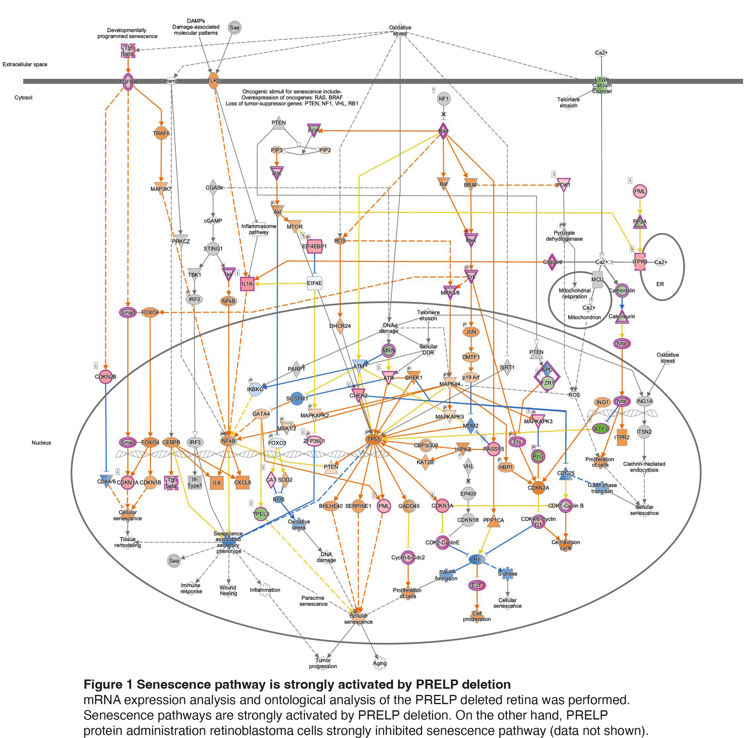

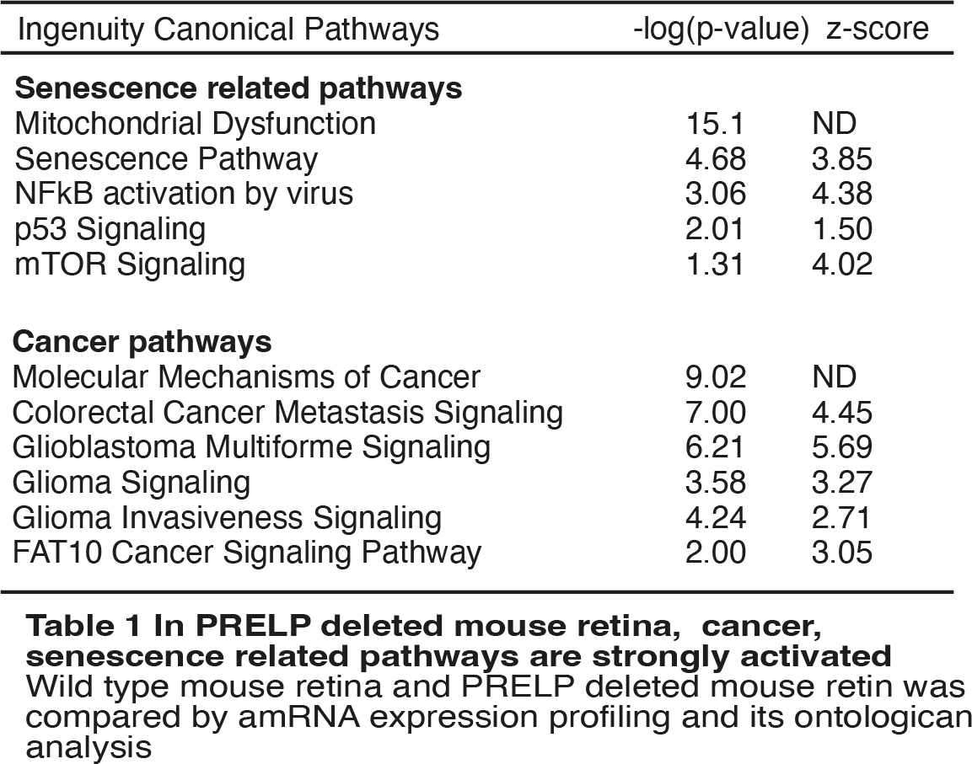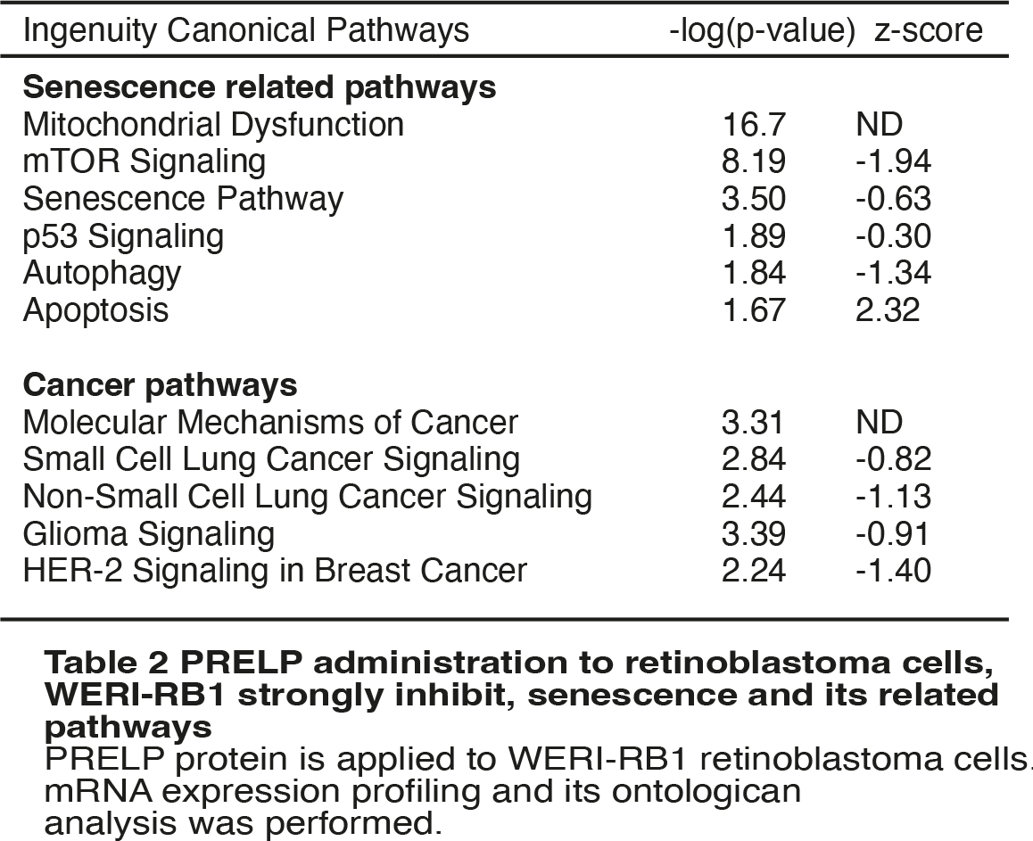

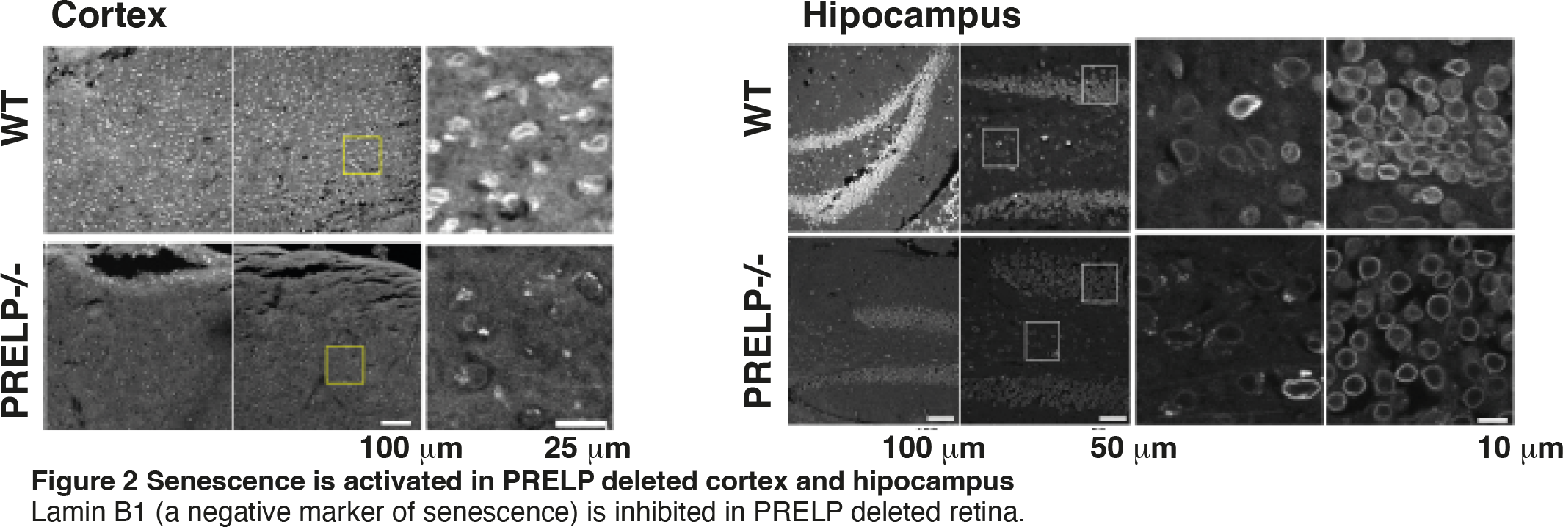

Cellular senescence refers to the condition where normally healthy cells lose their ability to divide, often as a response to various types of cellular stress, like DNA damage. This process is important for understanding aging and age-related diseases, including cancers (4-5). As cells age, senescent cells begin to build up in various tissues. Studies have shown that increasing the number of these cells in mice speeds up aging, while decreasing them can extend lifespan (6-7). Additionally, more senescent cells can accelerate the progression of age-related diseases, such as cancer, but this can be controlled by reducing the senescence levels.
Senescent cells release various substances known as the Senescence-Associated Secretory Phenotypes (SASP), which act as the effectors in their environment (5). Key features of senescent cells include changes in the function of intracellular organelles, such as abnormalities in lysosomes, mitochondrial dysfunction, stress in the endoplasmic reticulum, and alterations in the nuclear lamina, particularly the loss of lamin B1. There are also common markers of senescence including the activation of cell cycle inhibitors like p16INK4a, p21Cip1, and p53 (8). Certain signaling pathways such as NF-κB, mTOR, and Notch play crucial roles in senescence. They regulate the production of pro-inflammatory cytokines, chemokines, growth factors, and matrix metalloproteinases, which are all components of SASP. The activation of p21 and Notch-driven SASP typically occur early in the senescence process, while the increase in p16INK4a and NF-κB-driven SASP tend to happen at later stages.

The relationship between senescence and cancer is complex and can be contradictory (4,9). Originally, senescence was seen as a protective mechanism, halting the cell cycle in potentially cancerous cells and thus acting as a barrier to cancer development. However, recent research indicates that senescent cells can also promote cancer progression. These cells accumulate and enhance the Senescence-Associated Secretory Phenotypes (SASP), creating an environment that supports the development and growth of cancer. Experiments in mice have demonstrated that introducing senescent cells can lead to the onset of various cancers, whereas removing them can hinder cancer progression (10-11).
Additionally, cancer treatments like chemotherapy and radiotherapy can induce a condition known as "therapy-induced senescence" (TIS) in some cancer cells (4). While these cells stop multiplying, they may still contribute to treatment resistance and the recurrence of cancer (12). As a result, scientists are investigating ways to selectively remove senescent cells or block the effects of the SASP as new cancer treatment strategies. The drugs developed for these purposes are called senolytics, which eliminate senescent cells, and senomorphics, which inhibit the SASP.

Our research has discovered that PRELP directly interacts with a variety of Senescence-Associated Secretory Phenotypes (SASP) components, including TGF-β, EGF, IGFR, and p75NTR, effectively inhibiting their actions (2,3,13). Further studies showed that removing PRELP activates growth factor activities, whereas applying PRELP inhibits them. Additionally, we found that blocking PRELP activates almost all inflammation-related pathways (Table 3), while introducing PRELP reduces their activity (Table 4). Inflammation factors are crucial elements of SASP. These findings suggest that PRELP not only inhibits senescence but also serves as an inhibitor of SASP, playing a dual role in controlling these critical cellular processes.

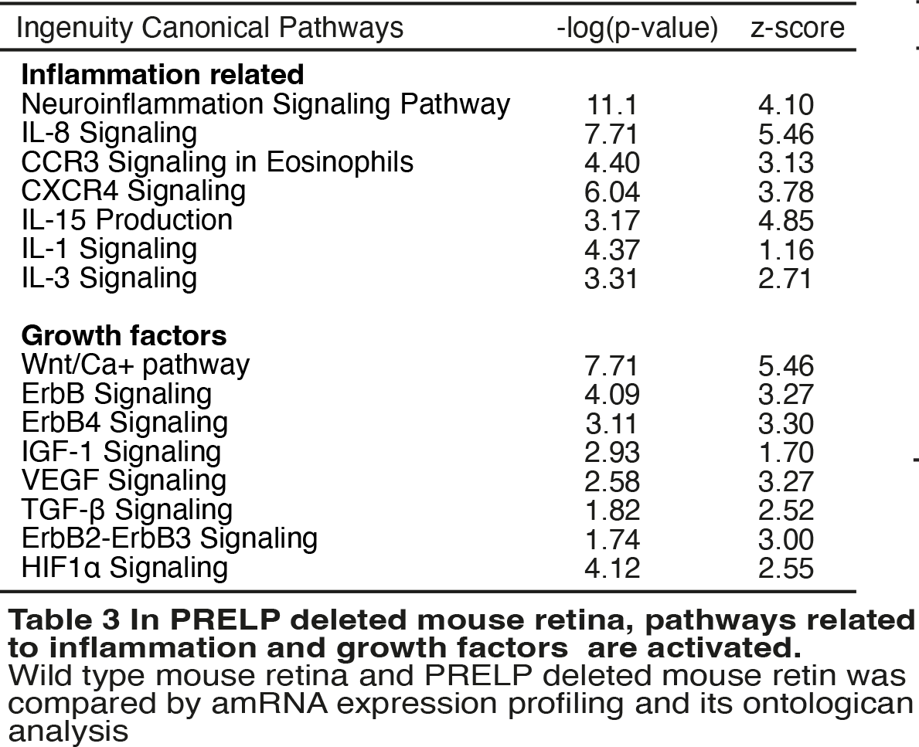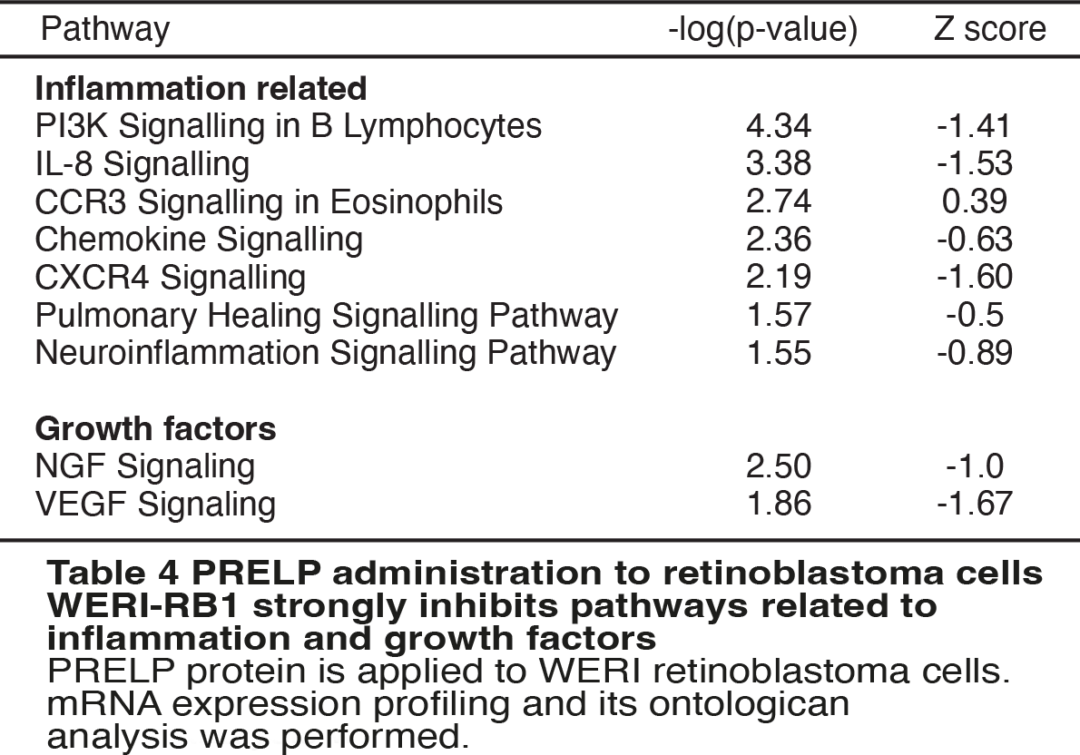

References (Our papers are bold)

1 Davies HR, Broad KD, Onadim Z, Price EA, Zou X, Sheriff I, Karaa EK, Scheimberg I, Reddy MA, Sagoo MS, Ohnuma SI, Nik-Zainal S. (2021) Whole-Genome Sequencing of Retinoblastoma Reveals the Diversity of Rearrangements Disrupting RB1 and Uncovers a Treatment-Related Mutational Signature. Cancers (Basel); 13(4):754
2 Papadaki, V. et al.s. “Two Secreted Proteoglycans, Activators of Urothelial Cell-Cell Adhesion, Negatively Contribute to Bladder Cancer Initiation and Progression of paper.” 2020. Cancers (Basel) Name volume (issue): pages/edition. 10.3390/cancers12113362.
3 Hopkins, J. et al.s. “PRELP Regulates Cell-Cell Adhesion and EMT and Inhibits Retinoblastoma Progression of paper.” 2022. Cancers (Basel) Name volume (issue): pages/edition. 10.3390/cancers14194926.
4 Schmitt, C. A., Wang, B. & Demaria, M.s. “Senescence and cancer - role and therapeutic opportunities of paper.” 2022. Nat Rev Clin Oncol Name volume (issue): pages/edition. 10.1038/s41571-022-00668-4.
5 Salama, R., Sadaie, M., Hoare, M. & Narita, M.s. “Cellular senescence and its effector programs of paper.” 2014. Genes Dev Name volume (issue): pages/edition. 10.1101/gad.235184.113.
6 Baker, D. J. et al.s. “Naturally occurring p16(Ink4a)-positive cells shorten healthy lifespan of paper.” 2016. Nature Name volume (issue): pages/edition. 10.1038/nature16932.
7 Amor, C. et al.s. “Senolytic CAR T cells reverse senescence-associated pathologies of paper.” 2020. Nature Name volume (issue): pages/edition. 10.1038/s41586-020-2403-9.
8 Gorgoulis, V. et al.s. “Cellular Senescence: Defining a Path Forward of paper.” 2019. Cell Name volume (issue): pages/edition. 10.1016/j.cell.2019.10.005.
9 Wang, L., Lankhorst, L. & Bernards, R.s. “Exploiting senescence for the treatment of cancer of paper.” 2022. Nat Rev Cancer Name volume (issue): pages/edition. 10.1038/s41568-022-00450-9.
10 Krtolica, A., Parrinello, S., Lockett, S., Desprez, P. Y. & Campisi, J.s. “Senescent fibroblasts promote epithelial cell growth and tumorigenesis: a link between cancer and aging of paper.” 2001. Proc Natl Acad Sci U S A Name volume (issue): pages/edition. 10.1073/pnas.211053698.
11 Dorr, J. R. et al.s. “Synthetic lethal metabolic targeting of cellular senescence in cancer therapy of paper.” 2013. Nature Name volume (issue): pages/edition. 10.1038/nature12437.
12 Ruhland, M. K. & Alspach, E.s. “Senescence and Immunoregulation in the Tumor Microenvironment of paper.” 2021. Front Cell Dev Biol Name volume (issue): pages/edition. 10.3389/fcell.2021.754069.
13 Kosuge, H. et al.s. “Proteomic identification and validation of novel interactions of the putative tumor suppressor PRELP with membrane proteins including IGFI-R and p75NTR of paper.” 2021. J Biol Chem Name volume (issue): pages/edition. 10.1016/j.jbc.2021.100278.

- If your aims and objectives changed during the course of the project, please explain why and in what way.

In our previous updates, we noted that obtaining fresh retinoblastoma samples has been challenging over the past two years. Improvements in retinoblastoma treatment, specifically in chemotherapy and radiotherapy, have resulted in enucleated eyes containing only small and fragile amounts of retinoblastoma tissue. These tissues are not suitable for in vitro culture or further cellular analysis. While these advancements are beneficial for patients, there remains a need to completely eliminate any residual retinoblastoma cells. As a result, we are adjusting our research approach. We are now focusing on studying the effects of PRELP using established human retinoblastoma cell lines instead of fresh tissue samples.

- Any problems or challenges impacting on the findings/results/outcomes of this project

Since we could not obtain freshly isolated retinoblastoma tissue, we could not examine importance of PRELP mediated inhibition of senescence on them.

- How will these fundings or outcomes impact patients or publish, and in what timetable? Do you foresee any obstacles/barriers to patients benefitting from the research findings?

We recently published a study proposing that using PRELP in treating retinoblastoma patients could potentially inhibit or even completely eradicate retinoblastoma cells. This treatment may also be effective against cancer drug-resistant and therapy-induced senescent retinoblastoma cells by targeting senescence and SASP. This approach could ideally complement chemotherapy in retinoblastoma treatment.
Developing PRELP as a treatment option involves several clear steps, though the process is expected to take at least five years:

Step-1: PRELP is secreted natural protein. We need to establish the production method of active recombinant PRELP protein.
Step-2: Established retinoblastoma cells are available. Using them, we need to prove that PRELP inhibits therapy induced resistant/senescent retinoblastoma cells.
Step-3: We need to understand the detailed mechanism.
Step-4: We need to develop method to obtain fresh therapy induced survived retinoblastoma cells.
Step-5: We need to prove that PRELP inhibits the isolated retinoblastoma cells.
Step-6: We need to complete clinical trial.

As we progress through steps 2 and 3, we anticipate that the PRELP-based research will generate further publications. To achieve these goals and conduct comprehensive experiments, we require adequate funding.

- Plain English summary (please refer to appendix 1).
Please provide a brief plain English summary of your final report above, including any findings or outcomes, and their potential impact on patients or the public. CHECT (and funding partners) will publish this summary in the public domain to demonstrate how we support research, therefore please do not include any confidential or commercially sensitive information.

Retinoblastoma is a severe eye cancer that primarily affects children. It originates in the retina and can develop rapidly, necessitating immediate treatment. Common treatments include chemotherapy and radiotherapy, but they are not always effective. Unfortunately, many children undergo surgery to remove their eyes to save their lives, resulting in blindness and significantly impacting their lives from a young age. There is a pressing need for better treatment methods.
Our research has identified a protein that is significantly suppressed in human retinoblastoma. Studies in mice have shown that lowering levels of this protein can accelerate cancer progression. Initially, we intended to study its effects on fresh human retinoblastoma tissues from patients, but the cells we isolated from patients treated with chemotherapy were not viable. Therefore, we shifted our focus to established human retinoblastoma cell lines.
Cancer treatments typically kill most cancer cells, but some robust cells survive and become drug-resistant. These resistant cells produce proteins that can accelerate cancer growth, making it crucial to target and eliminate them to enhance the effectiveness of cancer treatments. Our findings shows that this protein can damage drug-resistant retinoblastoma cells. Combining this protein with conventional chemotherapy could significantly improve the treatment of retinoblastoma, potentially reducing the need for surgical removal of the eyes and preventing blindness in many patients.

- Publications
Please list all published or accepted papers and abstracts from the work of this grant (journal style) (attach copies where available)

Hopkins J, et al. PRELP Regulates Cell-Cell Adhesion and EMT and Inhibits Retinoblastoma Progression. Cancers (2022). doi: 10.3390/cancers14194926.

- Dissemination of results
Please list where and by whom any results/findings have been disseminated (e.g. conferences, workshops, public engagement events)

No

- Intellectual property (IP)
Please list any IP arising from the research, and whether it is wholly owned by the researcher.

NA

- Collaborations
Please list any collaborations which have arisen during or as a result of this research.

Youichi Shinozaki, Ph. D.
Deputy Associate Director
Visual Research Project, Tokyo Metropolitan Institute of Medical Science
2-1-6 Kamikitazawa, Setagaya-ku, Tokyo, 156-8506, JAPAN

- Future research and funding
Please provide details of any further research/ideas planned and where potential funding will be sourced from as a result of this project

We are focusing on two main objectives to progress our project on retinoblastoma treatment. The first goal is to explore the role of PRELP as an inhibitor of therapy-induced senescence in retinoblastoma cells. The second goal is to develop a PRELP-mediated treatment approach for retinoblastoma.
Idea-1: A key strategy in cancer treatment involves targeting therapy-induced senescent cancer cells. Our aim is to demonstrate that PRELP can convert these senescent retinoblastoma cells, which have been induced by chemotherapy, back into sensitive cells. We are conducting experiments using human retinoblastoma cell lines, employing single cell analysis to study the effects of PRELP on chemotherapy-induced senescent cells. Additionally, we are investigating the combined impact of PRELP and chemotherapy drugs. Through cell biological analysis and mRNA expression profiling, we intend to uncover the detailed mechanisms of action. Funding for this part of the project is crucial, and we are hopeful that organizations like CHECT, and potentially match-up funding from Moorfields Eye Charity, will support this research, particularly for funding PhD students or postdocs.
Idea-2: Our ongoing aim is to develop new treatments for retinoblastoma. Currently, we are working on improving methods to produce GMP-grade active recombinant PRELP protein suitable for clinical trials. This requires substantial funding and collaboration with pharmaceutical companies, and we are in discussions with potential partners to support this initiative.

- Any further comments

We really appreciate about CHECT funding. We hope that we will continue to work together.

Report completed by: | Prof. Shin-ichi Ohnuma | Date of report: | 25/04/24

