Childhood Eye Cancer Trust (CHECT) Research Grant Final Report (end of grant report)

Please complete all sections of this report and return to petra.maxwell@chect.org.uk.

Project title: | Comparing Blood to Aqueous Humor as a Liquid Biopsy for Retinoblastoma: Determining the Superiority of the Aqueous Humor as a Source of Tumor DNA
Project reference: | 1901Berry2
Total award: | £50,000
Details of any additional funding:
Lead investigator: | Jesse L. Berry, MD | Administering institution: | Children’s Hospital Los Angeles
Start date of award: | October 14, 2019; re-awarded March 1, 2021 | End date of award: | October 31, 2022

- Final Report
Please structure your report as follows:

- Summary of findings/results/outcomes of this project (with reference to the aims and objectives stated in your original application).

Primary Aim:

To evaluate whether blood demonstrates similar potential as AH to be used as a liquid biopsy for retinoblastoma (RB) and whether tumor-derived cell-free DNA can be isolated as effectively from the blood as AH.

Progress:

We analyzed 60 samples of aqueous humor (AH) with whole genome sequencing (WGS) for tumor-derived DNA with somatic copy number alterations (SCNAs) over 2 years.

RB tumor DNA can be detected via two mechanisms, the first is via whole genome sequencing to detect somatic copy number alterations (SCNAs) which are small pieces of chromosomes. The second mechanism is to look for specific mutations in the RB1 gene.

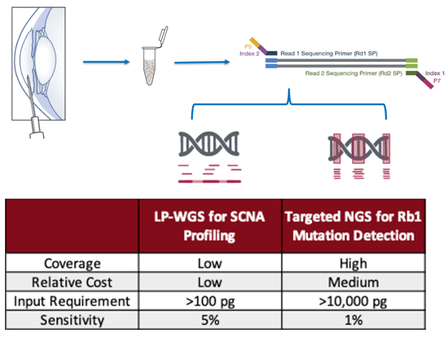
To detect SCNAs via whole genome sequencing requires approximately 5% or higher tumor fraction. This is consistently found in the AH (usually at levels >80% with active disease), however based on this research to date, supported by CHECT, we find SCNAs are rarely found in the blood because the tumor fraction is small. The reason is resistant or relapsed RB eyes will be enucleated before metastasis so tumor information is likely to be confined to ocular fluid due to blood ocular barrier.

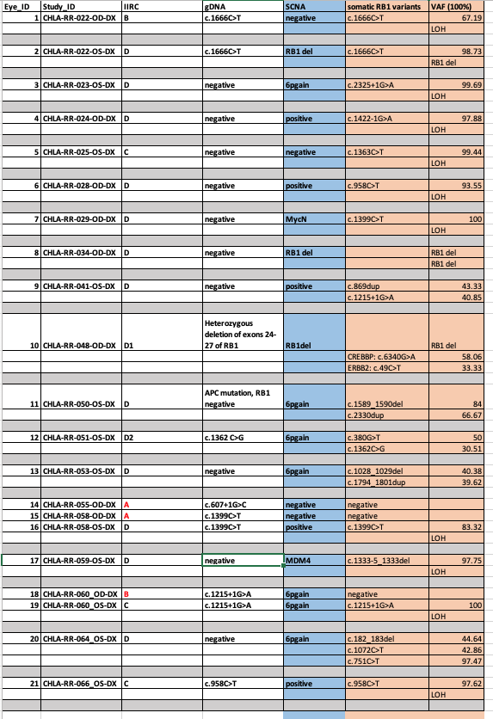
The threshold of detection of circulating DNA by targeted deep sequencing a single gene, such as RB1 gene, is <1% with at least 10ng (10, 000pg) DNA.
Figure 1: mechanisms for detection of tumor-derived DNA and required inputs

Sequencing has been completed on the 60 collected AH samples. Twenty-one of these samples were taken at diagnosis. DNA was detected in 100% of samples. We have confirmed the presence of tumor DNA via one or both mechanisms (SCNAs and RB1 mutations) in 19/21, 91% of diagnostic AH samples. We did not detect tumor DNA from two Group A eyes (with <3mm tumors) (Table 1).

The other AH samples were taken during therapy (at the time of intravitreal injections). It is known that these samples have a lower concentration of DNA. Nonetheless, 65% of samples have detectable tumor DNA with identifiable SCNAs. At diagnosis, 17/21 (81%) of samples had SCNAs detected with whole genome sequencing which is not unexpected given the higher tumor fraction. Of the 4 not detected, 2 were the same Group A. Thus, if we limit only to tumors >3mm the detection rate increases to 89%

Overall, it appears that our hypothesis for aim 1, which is that the AH is a high source of tumor-derived DNA (with a higher tumor fraction) is correct.
Table 1: RB1 and SCNA analysis of 21 diagnostic aqueous humor samples

Secondary Aim: A secondary aim is to evaluate the blood and AH for highly-recurrent somatic copy number alterations (SCNAs) which have prognostic significance for globe salvage.

We collected and sequenced 60 samples of blood, matched to the time of collection with the AH.

We have found the highest yield blood samples were those taken at the time of diagnosis and thus we focused on these samples (15/60 are samples taken at diagnosis with matched AH also taken at diagnosis).

As per previous reports, we have identified one child with a detectable SCNA in the blood with a tumor fraction of approximately 12%. Higher tumor fraction in the blood may be associated with increased risk of metastatic disease. Thus, we are watching this patient closely and there has been no metastatic disease at more than 18 months follow up. This is undergoing review for publication as, to our knowledge, this is the first time 6p gain (or any RB-related SCNAs) has been identified.

It remains to be seen whether: 1) the detection of 6p gain in the blood (such as the case shown above); or 2) the detection of any SCNAs at all (indicating any circulating tumor DNA >5% tumor fraction) is associated with risk for metastatic disease. Long term surveillance and follow-up is needed to validate this finding.

Figure 2: Genomic profiles

Upper panel: Whole genome sequencing of the DNA from the AH, taken at diagnosis of retinoblastoma, demonstrates several somatic copy number alterations: gain of 1q, 2p, loss of 3p, gain of 6p and gain of 13q.

Lower panel: Whole genome sequencing of a matched blood sample taken at diagnosis shows the presence of 6p gain, but none of the other SCNAs seen in the AH.

Given the low rate of SCNA detection as well as the low rate of metastatic disease, it seems that any blood-based approach will be best done via detection of mutations in the RB1 gene. We have optimized our pipelines to be able to detect tumor DNA via a tumor directed approach by first identifying the specific somatic mutations in the AH sample. It also appears based on work done at other centers that detection in the blood is only possible with very advanced tumors, >1cm, at diagnosis. This is in comparison to the ability to detect DNA from 3 mm tumors using the AH.

Overall, our conclusion from this research is that circulating tumor DNA can be detected in the blood but much less frequently and with much lower sensitivity than the AH. Because nearly half of children with retinoblastoma have tumors in BOTH eyes, the ability to separately evaluate them via the eye specific AH is also impactful. However, likely the detection of DNA in the blood is associated with very high-risk disease and it is possible these children should be treated with adjuvant chemotherapy or careful surveillance for metastatic disease. This requires careful follow up studies which are ongoing in many centers around the world.

- If your aims and objectives changed during the course of the project, please explain why and in what way.

N/A

- Any problems or challenges impacting on the findings / results / outcomes of this project.
None

- How will these findings or outcomes impact patients or the public, and in what timescale? Do you foresee any obstacles / barriers to patients benefitting from the research findings?

In the last 5 years there has been an explosion of research into liquid biopsy for RB, including both the aqueous humor and the blood as substrate. We are actively working towards a clinical test from the aqueous humor. While this research started at CHLA, several European centers (Birmingham Women’s and Children’s, UK and Institut Curie, France) are now actively involved in this exciting new arena of liquid biopsy research as well. Some centers are already using the aqueous humor to identify mutations in the RB1 gene (clinically, not just for research). A blood-based pan-cancer assay to detect RB1 mutations (but not chromosomal alterations) is clinically available from Sloan Kettering, NY. Ultimately, this research has huge translational impact to the care of RB patients and I expect in the next several years large specialty centers will be using the aqueous for prognostication of eye-related outcomes (like the likelihood of saving the eye with therapy); and blood for the prognostication of risk of metastatic disease (including when adjuvant chemotherapy may be needed to protect these children). This has been a very exciting aspect of this research.

- Plain English summary (please refer to appendix 1).
Please provide a brief plain English summary of your final report above, including any findings or outcomes, and their potential impact on patients or the public. CHECT (and funding partners) will publish this summary in the public domain to demonstrate how we support research, therefore please do not include any confidential or commercially sensitive information.

The ultimate goal of studying a liquid biopsy platform for retinoblastoma (RB) is to address the real clinical problems of 1) our inability to directly biopsy tumor tissue from the eye and 2) the resulting lack of quantitative diagnostic and prognostic molecular biomarkers for RB. In current practice, management and treatment decisions for RB patients are based almost entirely on clinical findings and the judgment and experience of the treating clinician. A better understanding of 1) how to safely obtain and analyze tumor-derived genetic information from the aqueous humor (AH) and blood and 2) the clinically relevant specific ocular biomarkers within AH could revolutionize how we prognosticate and care for these pediatric cancer patients.

The goal was to identify which biofluid was most likely to harbor tumor derived DNA, and specifically, highly-recurrent somatic copy number alterations (SCNAs), such as gain of chromosome 6p, which have prognostic significance. An approach that includes both the AH and the blood allows for both an organ-specific and systemic liquid biopsy approach to retinoblastoma.

Our primary conclusion at this time is that the AH has a higher yield and likelihood of detection of circulating DNA compared to the blood. Of samples of aqueous humor taken at diagnosis, 89% of samples have detectable tumor DNA if the tumor is at least 3mm in size. Blood is much less likely to show detection of SCNAs however it is not impossible as 1/60 in this group showed 6p gain in the blood. This is actually a really significant finding – and to our knowledge this is the first time that 6p gain has been identified in the blood. While the AH can provide really impactful information about the risk to the child’s eye from this cancer – it is the blood that can provide important information about the risk to the child’s life. Thus, identifying 6p gain in the blood provides important evidence that there is a role for monitoring the blood for tumor DNA as these children may be at increased risk of metastatic disease. Albeit rare in the US and UK, it is the most dreaded outcome in the care of children with RB. Thus, with CHECT’s support, we have additional evidence that evaluating the blood is important and, in the future, may be used to guide additional chemotherapy treatments the child may need.

The results of this study have the potential to not only impact clinical decision-making but to continue to move the field towards the implementation of personalized RB patient care – wherein decisions are made based not just on clinical findings but on molecular information from the tumor -- such as tumor DNA in the AH and/or the blood. With CHECT’s support, we have 12 new publications of our findings and multiple presentations at international conferences. We anticipate that the publication of these findings—including a detailed description of our experimental methods—will encourage additional centers to adopt a liquid biopsy program for the management of patients with retinoblastoma.

Several publications have been additionally featured in the public press as well as twice on the cover of Molecular Cancer Research, and recently we were awarded ‘Best of American Association for Cancer Research’ for the paper: ‘Chromosome 6p amplification in aqueous humor cell-free DNA is a prognostic biomarker for retinoblastoma ocular survival’ which was one of the most cited papers in 2020 and 2021. All of this increases exposure for this liquid biopsy research supported by CHECT. We will continue to work to spread the outcomes of this research across a wide audience from professionals to patients, families and the public at large. One route for this, has been via research presentations by Dr. Berry at 1 RB World, a retinoblastoma patient advocacy group, intended to educate parents, survivors and RB advocates at an annual meeting. We will work to communicate findings through CHLA and USC communication channels including its social media blog, which is available to the patients, families and the general public.

With the outcomes of this research supported by CHECT, we have submitted a R01 to the National Cancer Institute that proposed a dual AH and blood liquid biopsy platform. Ultimately, we plan to develop and publish an evidence-based set of surveillance and treatment guidelines for RB patients that are informed by the prognostic genomic information within AH and blood. Such guidelines could dramatically improve our ability to provide personalized care and counselling to RB patients and their families, particularly in the setting of advanced disease for which current clinical prognostication is difficult. More targeted and informed management could lead to improved quality of life for the children and families affected by RB, and more accurate prognostication could help to guide our treatment strategies and reduce unnecessary treatments in these vulnerable pediatric patients.

- Publications
Please list all published or accepted papers and abstracts from the work of this grant (journal style) (attach copies where available)

For the entire grant period to date, we have published 12 papers with the support of CHECT and we have acknowledged CHECT in all of them with the above statement.

Published
- Berry JL, Xu L, Polski A*, Jubran R, Kuhn P, Kim JW, Hicks J. Aqueous Humor is Superior to Blood as a Liquid Biopsy for Retinoblastoma. Ophthalmol. 127 (4): 552-554, 2020. doi.org/10.1016/j.ophtha.2019.10.026 PMID#31767439

- Xu L, Polski A, Prabakar RK, Reid MW, Chevez-Barrios P, Jubran R, Kim JW, Kuhn P, Cobrinik D, Hicks J, Berry JL. Chromosome 6p amplification in aqueous humor cell-free DNA is a prognostic biomarker for retinoblastoma ocular survival. Mol Cancer Res 2020;18(8):1166-1175. PMID#32434859, PMCID#PMC7415535, doi:10.1158/1541-7786.MCR-19-1262

- Polski A*, Xu L, Prabakar RK, Gai X, Kim JW, Shah R, Jubran R, Kuhn P, Cobrinik D, Hicks J, Berry JL. Variability in retinoblastoma genome stability is driven by age and not heritability. Genes Chromosomes Cancer. 2020; 59(10):584-590. PMID#32390242, PMCID#PMC7441809, doi: 10.1002/gcc.22859

- Polski A, Xu L, Prabakar RK, Kim JW, Jubran R, Shah R, Kuhn P, Cobrinik D, Hicks J, Berry JL. Cell-free DNA tumor fraction in the aqueous humor is associated with therapeutic response in retinoblastoma patients. Trans Vis Sci Tech. 2020;9(10):30. PMID#33062393, PMCID#PMC7533735, doi: 10.1167/tvst.9.10.30

- Xu L, Kim ME, Polski A, Prabakar RK, Shen L, Peng C, Reid M, Chevez-Barrios P, Kim JW, Shah R, Jubran R, Kuhn P, Cobrinik D, Biegel JA, Gai X, Hicks J, Berry JL. Establishing Clinical Utility of ctDNA Analysis for Diagnosis, Prognosis and Treatment Monitoring for Retinoblastoma: the Aqueous Humor Liquid Biopsy. Cancers 2021; 13: 1281. PMID#33805776, PMCID#PMC8001323, doi: 10.3390/cancers13061282

- Xu L, Shen L, Polski A*, Prabakar RK, Reid MW, Shah R, Jubran R, Kim JW, Biegel J, Kuhn P, Cobrinik D, Hicks J, Gai X, Berry JL. Simultaneous identification of clinically relevant RB1 mutations and somatic copy number alterations in the aqueous humor of retinoblastoma eyes. Ophthal Genet. 2020: 41:6, 526-532. PMID#32799607, PMCID: PMC7806277, doi: 10.1080/13816810.2020.1799417
***RB1 analysis is not an aim of the CHECT grant however some included samples sequencing analysis was done with support of the foundation and thus was included in to acknowledge support of CHECT

- Polski A, Xu L, Prabakar RK, Kim JW, Jubran R, Shah R, Kuhn P, Cobrinik D, Hicks J, Berry JL. Cell-free DNA tumor fraction in the aqueous humor is associated with therapeutic response in retinoblastoma patients. Trans Vis Sci Tech. 2020;9(10):30. PMID#33062393, PMCID#PMC7533735, doi: 10.1167/tvst.9.10.30

- Xu L, Kim ME, Polski A, Prabakar RK, Shen L, Peng C, Reid M, Chevez-Barrios P, Kim JW, Shah R, Jubran R, Kuhn P, Cobrinik D, Biegel JA, Gai X, Hicks J, Berry JL. Establishing Clinical Utility of ctDNA Analysis for Diagnosis, Prognosis and Treatment Monitoring for Retinoblastoma: the Aqueous Humor Liquid Biopsy. Cancers 2021; 13: 1281. PMID#33805776, PMCID#PMC8001323, doi: 10.3390/cancers13061282

- Kim ME, Polski A, Xu L, Prabakar R, Peng C, Reid MW, Shah R, Kuhn P, Cobrinik D, Hicks J, Berry JL. Comprehensive Somatic Copy Number Analysis Using the Aqueous Humor Liquid Biopsy for Retinoblastoma. Cancers 2021; 13, 3340. PMID#34283049, PMCID#PMC8268955, doi.org/10.3390/cancers13133340

- Wong E, Xu L, Shen L, Kim ME, Polski A, Prabakar RK, Shah R, Jubran R, Kim JW, Biegel J, Gai X, Kuhn P, Hicks J, Berry JL. Inter-eye genomic heterogeneity in bilateral retinoblastoma via aqueous humor liquid biopsy. npj Precision Oncology 2021; doi.org/10.1038/s41698-021-00212-0

- Kim ME*, Xu L, Prabakar RK, Shen L, Peng C, Kuhn P, Gai X, Hicks J, Berry JL. Aqueous Humor as a Liquid Biopsy for Retinoblastoma: Clear Corneal Paracentesis and Genomic Analysis. J Vis Exp. 2021; 7:175. PMID#34570090, doi:10.3791/62939

- Li H, Xu L, Weisenberger DJ, Li M, Zhou W, Peng C, Stachelek K, Cobrinik DC, Liang G, Berry JL. Characterizing DNA methylation signatures of retinoblastoma using the aqueous humor liquid biopsy. Nature Comm. 2022 (epub ahead of print) doi.org/10.1038/s41467-022-33248-2

- A report detailing the detection of 6p gain in the blood of the single patient was just submitted for review; it will acknowledge CHECT at publication as well.

- Dissemination of results
Please list where and by whom any results/findings have been disseminated (e.g., conferences, workshops, public engagement events)

We presented our work 15 occasions with the support of CHECT; all have acknowledged the support of CHECT in each case – a copy of a poster is below.

- Aqueous Humor is Superior to Blood as a Liquid Biopsy for Retinoblastoma. American Academy of Ophthalmology. San Francisco, CA. 2019

- Gain of Chromosome 6p is a molecular biomarker for prognostication of retinoblastoma ocular survival: the aqueous humor surrogate tumor biopsy. American Association for Cancer Research (AACR) and Association for Research in Vision and Ophthalmology (ARVO) 2020

- Longitudinal Aqueous Humor Sampling reflects treatment response in retinoblastoma patients. Association for Cancer Research (AACR) and Association for Research in Vision and Ophthalmology (ARVO) 2020

- Simultaneous identification of clinically relevant RB1 mutations and somatic copy number alterations in the aqueous humor of retinoblastoma eyes. American Academy of Ophthalmology (AAO) November 2020 and American Association of Cancer Research (AACR) April 2020. (virtual for Covid)

- Establishing Clinical Utility of ctDNA Analysis for Diagnosis, Prognosis and Treatment Monitoring of Retinoblastoma: the Aqueous Humor Liquid Biopsy. Association for Cancer Research (AACR) 2021 and Association for Research in Vision and Ophthalmology (ARVO) 2021 (virtual for Covid-19)

- Inter-eye genomic heterogeneity in bilateral retinoblastoma via aqueous humor liquid biopsy. Association for Research in Vision and Ophthalmology (ARVO) 2021 and Association for Cancer Research (AACR) 2021 (virtual for Covid-19)

- Comprehensive somatic copy number analysis using the aqueous humor liquid biopsy for retinoblastoma. Association for Research in Vision and Ophthalmology (ARVO) 2021 (virtual for Covid-19) *awarded Knights Templar Eye Foundation Virtual Travel Grant Award.

- Chromosome 6p amplification detected in blood cell-free DNA in advanced retinoblastoma. Association for Research in Vision and Ophthalmology (ARVO) May 2022, Denver, CO – this presentation will detail the patient with 6p gain in the blood and AH.
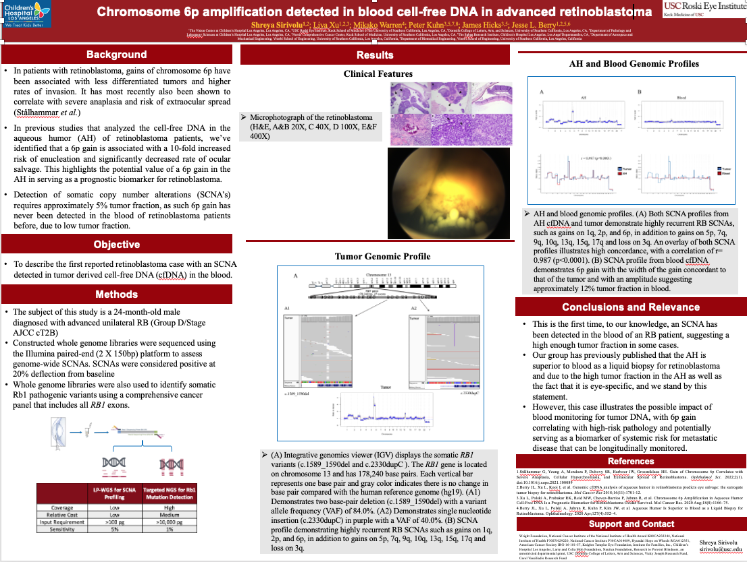

- What can the aqueous humor liquid biopsy do? Establishing clinical utility of ctDNA analysis for diagnosis, prognosis and treatment monitoring of retinoblastoma. International Society of Ocular Oncology (ISOO). June 2022, Leiden, Netherlands. Selected for oral presentation.

- Inter-eye genomic heterogeneity in bilateral retinoblastoma via aqueous humor liquid biopsy. International Society of Ocular Oncology (ISOO). June 2022, Leiden, Netherlands. Selected for oral presentation.

- Intellectual property (IP)
Please list any IP arising from the research, and whether it is wholly owned by the researcher.

Aqueous humor cell free DNA for diagnostic and Prognostic evaluation of Ophthalmic Disease
62/654,160
(Berry, Xu, Hicks)

This is held by Children’s Hospital Los Angeles and the University of Southern California.

- Collaborations
Please list any collaborations which have arisen during or as a result of this research.

Due to the success of this and other projects focused on the Aqueous Humor as a liquid biopsy for retinoblastoma, we have established a cooperative research consortium to receive samples from 15 RB centers around North America including: Wills Eye Hospital, St. Jude’s Cancer Center, MD Anderson Cancer Center, Boston Children’s Hospital, Sick Kids Toronto, Seattle Children’s Hospital, Phoenix Children’s Hospital, Lurie Children’s Hospital, Emory, Bascom Palmer Eye Institute, Moran Eye Center, Oregon Health & Science University, Duke, University of California, San Diego & San Francisco. We also have an established collaboration with Children’s Oncology Group via study ARET2121 in which we expect ~90 AH samples from ~30 patients. An active IRB, Material Transfer Agreements, and consents are maintained at each center.

- Future research and funding
Please provide details of any further research/ideas planned and where potential funding will be sourced from as a result of this project

We have just submitted an R01 to the National Cancer Institute entitled: Validation of an aqueous humor liquid biopsy for molecular prognostication and monitoring of children with retinoblastoma; this included both AH for the eye and blood for systemic monitoring. This would not have been possible without the support of CHECT.

- Any further comments

It has been a joy to be funded by CHECT. The retinoblastoma research community is small and I am glad we are all working towards a better future for these children.
Report completed by: | Jesse L. Berry, MD | Date of report: | 10/4/2022

Appendix 1: Writing a plain English summary in your Childhood Eye Cancer Trust (CHECT) final report

A plain English summary is a clear explanation of your research that should be accessible by an interested audience.

Your final report will be reviewed by experts on the CHECT Scientific Advisory Committee but also by lay members of the SAC and CHECT Board members who are not scientific experts. It will also be accessible through the CHECT website.
A good quality plain English summary providing an easy to read overview of your whole study will help:
- those carrying out the review (reviewers and Board and panel members) to have a better understanding of your research
- inform others about your research such as those affected by retinoblastoma (Rb), members of the public, health professionals, policy makers and the media
- research funders to publicise the research that they fund.
The summary is important. If it is felt that your plain English summary is not clear and of a good quality then you may be required to amend your summary prior to the final closure of the project.

What to include in your plain English summary
Your plain English summary should be 300 words or less. When writing the summary consider including the following information:
- Aim(s) of the research
- Findings or outcomes
- Potential impact on Rb individuals and families

How to write a plain English summary

The people who will read your summary will be an interested audience, but are not necessarily specialists. Therefore write your summary with this audience in mind, for example at the same level as an article in a newspaper.
There are a few simple rules for writing in plain English. In summary these are:

- Avoid wherever possible using jargon, abbreviations and technical terms. If you have to use them provide a clear explanation
- Avoid complicated English or uncommon words
- Use active not passive phrases: for example say ‘we will do it’ rather than ‘it will be done by us’
- Keep sentences short
- Think about the order and structure
- Break up the text. For example use bullet lists
- Ask patients / carers / colleagues to read a draft to find out if anything is unclear.

The plain English summary is not the same as a scientific abstract. Please do not cut and paste this or other sections of your final report to create the plain English summary. Further guidance on plain English summaries for research is available at:
- www.amrc.org.uk/blog/how-to-write-a-lay-summary-of-a-research-project

- www.cancerresearchuk.org/funding-for-researchers/patient-involvement-toolkit-for-researchers/planning-your-patient-involvement/writing-for-a-lay-audience

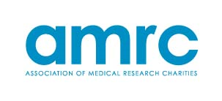

Based on the NIHR guidance available at https://www.nihr.ac.uk/about-us/CCF/PPI/Plain_English_summaries_in_National_Institute_for_Health_Research_funded_research.pdf

