2020

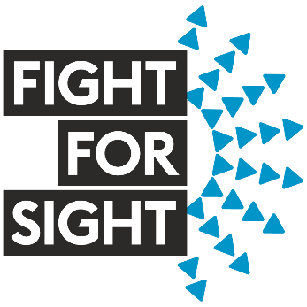

Final Grant Report

The Final Report form must be submitted within three months of the end date of the grant. The aim of the report is to validate the completion of the grant and report on immediate impact of Fight for Sight’s funding. Reports will be shared with partner organisations that have helped co-fund the research. Completed forms should be emailed to grants@fightforsight.org.uk. Please note that the final grant payment will be held until satisfactory receipt of the report.

Date of report | 10th November 2022

- Grant Details
Lead applicant | Dr Amy Gerrish
Position/Professional title | Research and Development Scientist
Institution | Birmingham Women’s and Children's NHS Foundation Trust
Telephone contact | 0121 335 8036 ext. 5743
Type of grant | Small Grant 2020
Grant reference number | U/24CEC21
Start date | 1 August 2021
End date | 31 July 2022
Grant value | £14,851

Co-applicants and collaborators
Please provide the names of the co-applicants and collaborators (including commercial/industry) involved in the grant as per the grant application. Separate individuals with a “,”
Co-applicants | Stephanie Allen, Trevor Cole, Manoj Parulekar
Collaborators | M. Ashwin Reddy

Supported researchers
Please provide the names of postdoctoral researchers, PhD students or other staff directly supported (in receipt of grant salary) by this grant. Fight for Sight wishes to build relationships with all researchers involved in the grant and therefore email contact details are requested.
Post 1 | Not Applicable
Name
Email

Animal licences (if applicable)
PPL reference | Not Applicable
PIL reference
Animal species
Were the animals genetically modified? |  | Yes☐ No☐
Optional comments

Patient and public involvement (if applicable)
Please provide any details of the involvement of patients/public in the project.
This project involves the analysis of clinical history and samples taken from retinoblastoma patients diagnosed in the UK, who are often <5 years old. These patients have been recruited from those undergoing treatment for retinoblastoma at one of two national specialised centres at the Birmingham Children’s Hospital and Royal London Hospital.

Ethical approval (if applicable)
Body ethics approval is sought from | REC & HRA
Submission date | January 2017
Approval date | 21st February 2017
Optional comments
IRAS project ID 189947. REC reference:16/EE/0528
Additional substantial amendments were approved in August 2020 and February 2022

Clinical research (if applicable)
The UKCRN provides infrastructure to support high-quality clinical research studies for the benefit of patients. If your grant involves patients, please provide your UKCRN study ID. If your grant is registered with the UK Clinical Trials Gateway, please provide your reference number. Alternatively describe why you have not utilised these services.
UKCRN study ID | CPMS ID 51564
UK Clinical Trials Gateway
Optional comments We are looking into registering on the UK trials gateway via https://www.isrctn.com as part of our continued project funding through Fight for Sight

Delays
Please detail any delays or issues during the lifetime of the grant. This may include unforeseen delays in recruiting patients or research staff.
Since this grant was awarded, the sequencing reagents (SeqCap) we used for the analysis of ocular cell-free DNA, as well as our non-invasive prenatal diagnosis (NIPD) service, were discontinued by Roche. We have therefore had to re-design and validate our tests using their new targeted sequencing system (HyperCap). This validation was particularly extensive for our clinical NIPD service and was performed by Amy Gerrish. Due to her availability and the initial validation required, this start of this project was delayed from May 2021 to August 2021. However, patient recruitment was ongoing during this period.

During the span of this grant funding, the West Midlands Regional Genetic Laboratory has had significant issues with bioinformatics capacity. This has impacted both clinical service improvements as well as any new service developments/research within the department. Bioinformatics support for this project has therefore been severely restricted. This has particularly affected the outcome of Aim 3: to investigate the potential of our assay to detect putative prognostic markers in ocular fluid. Further details are given in the Achievements section.

- Research Project
Project title
Further investigation into intra-ocular fluid as a liquid biopsy in retinoblastoma

Abstract
Please provide an abstract of your research or modify the version below (250 words).
Retinoblastoma is the most common childhood eye cancer. It has a birth incidence of 1 in 15,000-20,000 and usually occurs before the age of three. All cases of heritable retinoblastoma, and at least 98% of non-heritable retinoblastoma, result from loss or reduction of expression of both copies of the RB1 gene. Due to the risk of cancer spread, a retinoblastoma tumour cannot be directly biopsied. As a result, diagnosis of non-heritable retinoblastoma requires tumour tissue, obtained following eye removal (enucleation). Furthermore, prognostication has been limited to either in situ assessment or histopathological analysis from enucleated tumour tissue, to detect high-risk pathology features. As therapeutic options improve, enucleation rates are in decline. Consequently, new avenues for both diagnosis and prognosis of retinoblastoma are required. The analysis of tumour-derived cell-free DNA (cfDNA), within samples taken from retinoblastoma patients, often termed liquid biopsy, offers significant potential as an alternative to current procedures (Gerrish et
al 2021). We have recently developed a genetic diagnostic assay for non-heritable retinoblastoma using next-generation sequencing, which can detect somatic RB1 mutations in cfDNA from intra-ocular fluid (Gerrish et al 2019). In this project we will further validate our intra-ocular fluid diagnostic assay. We also plan determine whether detection of chromosomal copy number variation, identified as putative prognostic markers for retinoblastoma, can also be achieved using our targeted sequencing assay.

Gerrish A, et al 2019. Br J Ophthalmol. 2019 Feb 11;103(5):721–4.
Gerrish A, et al 2021. Cancers (Basel). 2021 Mar 29;13(7):1570.

Research agenda
Please describe in lay terms how this grant and research project fits in and contributes to the overall research agenda of your host department, and how the project relates to other external research. Please also describe how this grant relates to other Fight for Sight funding you have received. This will allow Fight for Sight contextualise your grant achievements within an overarching research strategy (no more than 500 words).
At the West Midlands Regional Genetics Laboratory (WM RGL) we have a strong background in the development of genetic diagnostic tests using cell-free DNA analysis. This includes non-invasive prenatal testing (NIPT) for chromosomal disorders such as Down’s syndrome and non-invasive diagnosis (NIPD) for single gene disorders such as spinal muscular atrophy and cystic fibrosis. Both NIPT and NIPD detect cell-free DNA from the unborn baby in the blood of the pregnant women. We have recently developed NIPD for heritable retinoblastoma (Gerrish et al 2020), which was adopted onto the national genetic test directory in April 2022 and received considerable media coverage.

The analysis of tumour-derived cell-free DNA (cfDNA) in ocular fluid or blood, offers significant potential as an alternative to current diagnostic and prognostic procedures in retinoblastoma. At the Birmingham Women’s and Children’s NHS Foundation Trust we are at the forefront of these developments. We are one of two global research groups leading on the genetic analysis of ocular cfDNA in retinoblastoma. Through intra-trust collaboration between the Birmingham retinoblastoma eye service and the WM RGL, we have developed a genetic diagnostic assay for retinoblastoma, which can detect RB1 mutations carried by the tumour, in cell-free DNA from ocular fluid.

The second research group working in this area, led by Jesse Berry in the USA, initially published on the identification of genetic markers associated with poor treatment response through whole genome sequencing of ocular cell-free DNA from retinoblastoma patients. Following our research on the diagnosis of retinoblastoma using targeted sequencing of the RB1 gene, Berry and colleagues have developed a two-step sequencing approach to provide both diagnostic and prognostic information for retinoblastoma patients. Within this project we hope to develop a single test to generate this information, which will be more cost effective and more appropriate given the limited levels of cell-free DNA that are available from these samples.

Gerrish A, et al 2020. J Clin Med. 2020 Oct 30;9(11):3517.

Overall aims and objectives
Please detail in lay terms the original aims and objectives of the grant. Please highlight any changes and justify why these changes were made (200 words).
The original objectives of our project were to:
1) Analyse ocular fluid samples from 10 patients undergoing intra-vitreal chemotherapy (IViC) to further validate our genetic test for the diagnosis of non-heritable retinoblastoma
2) Analyse serial ocular fluid samples from patients taken during consecutive IViC sessions to see if these could be used to monitor treatment success
3) Investigate the potential of a combined genetic test for the diagnosis and prognosis of retinoblastoma using ocular fluid.
4) Initiate a formal collaboration with BARTs NHS trust for the nationwide recruitment of ocular fluid samples from retinoblastoma patients.

These objectives still represent the overall aims of this project. However our data of ocular fluid samples from patients undergoing intra-vitreal chemotherapy, suggested that, in contrast to fluid samples from treatment naive enucleated eyes, they do not always have the required cell-free DNA (cfDNA) concentration for sequencing analysis to be possible. We therefore revised our sample collection protocol, to collect ocular fluid earlier in the treatment process, after only 1-2 rounds of systemic chemotherapy, where we predicted tumour load and therefore cfDNA levels will be significantly higher.

Achievements
Please provide a lay summary of the project achievements in relation to the aims, objectives and milestones of the grant. Also highlight any additional discoveries that were not originally envisaged (no more than 1,000 words). Please include any relevant images or figures that help illustrate your achievements.
Aim 1 : Analyse ocular fluid samples from 10 patients undergoing intra-vitreal chemotherapy (IViC) to further validate our genetic test for the diagnosis of non-heritable retinoblastoma

Due to a discontinuation of the reagents used in our original sequencing assay, to complete this aim we first were required to re-design our targeted next-generation sequencing assay. We validated this new design using cell-free DNA (cfDNA) derived from the ocular fluid of nine patients who have undergone an eye enucleation (removal) as part of their treatment. As these patients had undergone eye removal, results from routine molecular diagnostic testing on the tumour were available.

Cell-free DNA was detected in 7/9 of the ocular fluid samples and we subsequently identified RB1 pathogenic mutations in these 7 samples. These were concordant with the paired tumour DNA sample, where available (n=6) plus the independent clinical diagnostic report.

Our findings therefore confirmed that our re-designed targeted sequencing assay is able to generate information for the diagnosis of non-heritable retinoblastoma from ocular fluid which is comparable with current molecular testing of tumour DNA, the gold standard. We therefore subsequently tested ocular fluid samples from patients who would clinically benefit from this test, those undergoing treatment to save their eye, where tumour DNA is unavailable.

We have sequenced cfDNA from 25 ocular fluid samples from 20 patients undergoing eye conservation treatment. Ten of these samples were from diagnostic ocular fluid taps (taken after 1-2 cycles of systemic chemotherapy, specifically for genetic testing). The remaining ocular fluid samples were taken as part of routine intra-vitreal chemotherapy (IViC) treatment, which is often after 4-6 cycles of systemic chemotherapy.

We have found that cfDNA levels and therefore sequencing quality and our ability to identify RB1 pathogenic variants, was highly correlated with sample type (Figure 1). A diagnostic result (detection of ≥2 RB1 pathogenic variants) was obtained in 75% of diagnostic tap samples compared to only 40% of samples taken during IViC. Somatic single nucleotide variant (SNV) frequency confirmed our previous observation (Gerrish et al 2019) that >80% of total ocular cfDNA originated from the tumour.

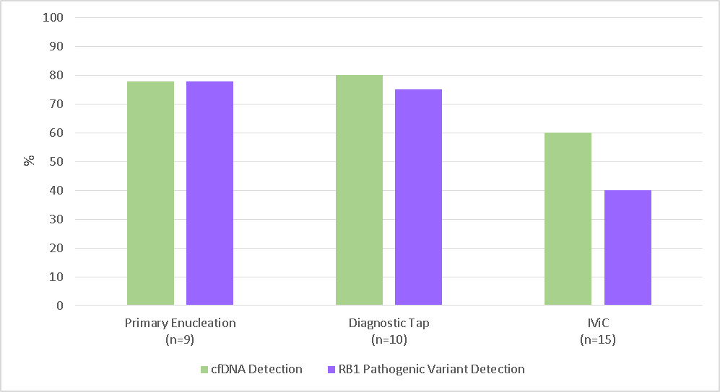

Figure 1. Detection of cell-free DNA and RB1 pathogenic variants in ocular fluid taken from primary (treatment naive) enucleated eyes, eyes that have undergone a diagnostic tap and eyes being treated with IViC,

Our main achievement within this objective was to show for the first time that, in order for this assay to be successful enough for implementation into clinic, ocular fluid samples should be collected prior to significant chemotherapy treatment.

Aim 2: Analyse of serial ocular fluid samples from patients taken during consecutive IViC sessions to see if these could be used to monitor treatment success

We have analysed serial ocular fluid samples (n=2) from five patients undergoing IViC. We were able to detect cfDNA and identify two RB1 pathogenic variants in both serial samples in 2/5 patients analysed. The first patient was found to be resistant to treatment and subsequently required a secondary enucleation. The second patient is still currently undergoing treatment. Samples from the other three patients had significantly reduced or no detectable cfDNA in at least one of their samples, which resulted in sequencing failure.

Our conclusion from this work is that the use of cell-free DNA concentration as a marker of treatment resistance may be possible, but requires further investigation. However the monitoring of treatment response using sequencing data, such as RB1 allele frequency, is unlikely to be possible, due to the lack on baseline data available when no cfDNA is present.

Aim 3: Investigate the potential of a combined genetic test for the diagnosis and prognosis of retinoblastoma using ocular fluid through the analysis of both the RB1 gene and other regions of the genome known to be associated with aggressive disease.

As well as targeting the RB1 gene, our re-designed assay targeted regions of the genome which are recurrently altered in retinoblastoma tumours, which are thought to be associated with a more aggressive disease. This included the genes MYCN and BCOR plus chromosomes 1, 2, 6, 16, 7, 19, 21. We have therefore sequenced these regions in all samples described in Aims 1&2, where cfDNA was detected (n=24).

We have identified both chr1q and 6p amplifications, in ocular fluid from enucleated eyes (Figure 2) as well as alterations on chromosome 1, 6 and in several patients undergoing conservative treatment. Furthermore we have detected a MYCN and chromosome 6p amplification in a patient where chemotherapy treatment failed and they subsequently required an enucleation.

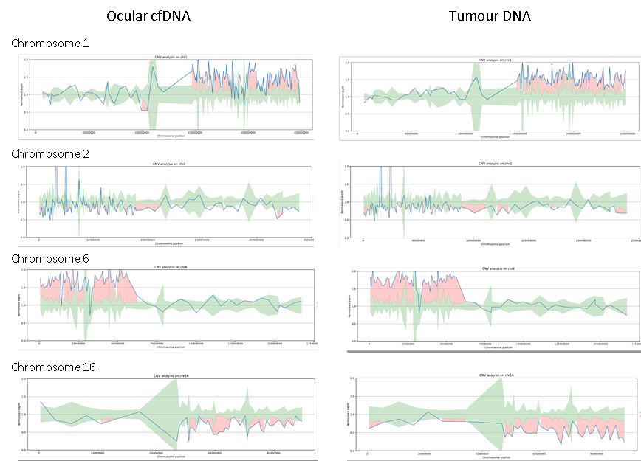

Figure 2. Examples of the detection of copy number alterations on Chromosome 1, 2, 6 and 16 in ocular fluid cfDNA and paired tumour DNA. Relative read depths outside the expected range (green), indicating a copy number alteration, are shown in red.

These findings suggests that our targeted capture assay could be used to generate both diagnostic and prognostic information for retinoblastoma patients. While this is encouraging, the bioinformatic issues outlined above, have meant that further development of the assay to refine the detection of non-RB1 copy-number variants (CNV) in ocular fluid cfDNA has been limited. We have, however, been able to generate significant sequencing data within this project. This data will be analysed further within our Fight for Sight grant (5177 / 5178), commencing in January 23. Within this project we have funds to recruit a dedicated bioinformatician.

Aim 4: Initiation of a formal collaboration with BARTs NHS trust for the nationwide recruitment of ocular fluid samples from retinoblastoma patients.

The Royal London Hospital, BARTS NHS Health Trust has been set up as a recruitment site for this project. Between July 2020 and September 2022, 13 patients have been recruited and 35 ocular fluid samples have been transported to WM RGL at BWH for analysis. We therefore have national recruitment of ocular fluid samples from retinoblastoma patients. This collaboration is continuing through our Fight for Sight grant (5177 / 5178), which will commence in January 2023.

Implication of research for patients affected by sight loss
Please provide a lay description of the tangible and prospective implications of the research and what it means to patients affected by sight loss (no more than 300 words).
As therapeutic options for retinoblastoma improve, and enucleation (eye removal) rates decline, access to tumour tissue is decreasing and with it, the opportunity to identify the genetic changes in the tumour that have caused the retinoblastoma. This project has shown that the analysis of cell-free DNA within ocular fluid can be used as an alternative to tumour tissue for the diagnosis of non-heritable retinoblastoma. Furthermore, we have determined the optimal time point for ocular fluid collection to maximise diagnostic rate. This will be essential to facilitate implementation into clinical service, which is planned within the next 24 months.

The distinction between heritable and non-heritable retinoblastoma is vital, as heritable cases need close monitoring; in childhood for the presence of new tumours in the eye and later in life for other cancers outside of the eye. There are also important implications for both siblings and offspring. Confirming the non-heritable nature of the retinoblastoma can avoid screening examinations, which often include the need for repeated general anaesthetics over a number of years, not only in the patient but also family members. As well as beneficial to patients and their families, this would provide significant cost savings to the healthcare system.

As well as using cell-free DNA within ocular fluid to diagnose retinoblastoma, the detection of other genetic markers may identify tumours more resistant to treatment and therefore associated with poor prognosis for saving the eye. Clinical implementation of this test could identify cases best managed with immediate enucleation and avoid a cohort of patients with failed chemotherapy. Within this project we have shown that both diagnostic and prognostic information can be determined from the same combined genetic test, which may be essential for clinical implementation, given the limited amount of ocular fluid/cfDNA available for testing.

Please provide a quote from the researcher/s that could be used in a press release that explains the importance of Fight for Sight’s specific funding. You may want to include quotes from members of your research team who have received salary as part of the grant.
The funding we have received from Fight for Sight and CHECT has been crucial to allow us to continue our work to develop new genetic tests for both the diagnosis and prognosis of retinoblastoma. These tests analyse tumour DNA found in eye fluid and could help doctors determine the best care plan for retinoblastoma patients and their families. Specifically through this funding, we have determined that the timing of sample collection is critically important for the tests to work. This information will be essential in order to implement these tests into clinical service.

- Research outputs to date
Publications
Please give details (author, title, journal and whether it was open access) of accepted (in press/published) peer-reviewed publications resulting from the work supported by this grant author to date.

Published

Submitted

In preparation
Gerrish et al “Diagnosis of retinoblastoma using aqueous humour – findings from an extended cohort”.

Conferences and meetings
Please give details (conference author, title and) of oral/poster presentations at national/international conferences that specifically relate to the grant. Mark any awards that were associated with the conference. Add rows if necessary.
Conference | Author, title | Oral or poster | Associated awards (Y/N)
Student Midwives Conference, University of Wolverhampton | Amy Gerrish “Advances in genetic testing in Retinoblastoma –  the potential of cell-free DNA” | Invited Oral | N/A

Patient and public engagement activities
Please provide details of any other communication/public engagement activities e.g. presentations to non-academic audiences, public support groups, healthcare professionals etc. You should include any media attention received as a result of the research.
Amy Gerrish created a short video for the CHECT charity explaining our research, which has been included in their May 2022 newsletter and published on their website

https://chect.org.uk/transforming-the-treatment-of-childrens-eye-cancer/

In November 2022, Amy Gerrish presented at a Student Midwives Conference at Wolverhampton University. Within this presentation she covered both the diagnosis of retinoblastoma using ocular fluid, work funded by Fight for Sight/CHECT, as well as non-invasive prenatal testing of heritable retinoblastoma.

Amy Gerrish has also been invited to give a talk to the North Yorkshire and South Durham Optometrists Association in February 2023.

In April 2022, our non-invasive prenatal diagnostic test for retinoblastoma was incorporated into the genetic test directory. This received significant media coverage. Within this coverage we mentioned our parallel work on developing a postnatal test for retinoblastoma using cell-free DNA from ocular fluid.

https://www.england.nhs.uk/2022/05/babies-to-get-new-test-for-eye-cancer-in-the-womb-to-save-their-sight/

The story ran on The Today programme and BBC News at 3pm, 5pm and 6pm. It featured on 8 major newspapers and websites as well as more than 20 articles across regional papers and online sites.

In September 2021, with the help of the Birmingham Women’s and Children’s NHS press office, we published an article on our research into the use of cell-free DNA in retinoblastoma. This focused mainly on our cfDNA analysis for non-invasive prenatal diagnosis but also mentioned our analysis of eye fluid for postnatal diagnosis of non-heritable retinoblastoma. This article was published on the trust website, and BCH charity facebook page and a press release was also produced.

https://bwc.nhs.uk/news/leading-the-way-in-childhood-eye-cancer-treatment-with-groundbreaking-new-research-3821/

Amy Gerrish frequently uses her twitter feed @amygerrish to publicise the work of the group and acknowledge funders.

Collaborations and partnerships
Please describe any collaborations or partnerships that have formed as a result of the grant. This includes other academic groups outside the current proposal or with commercial/industry partners.
This grant has facilitated a collaboration with Bart NHS Trust for the nationwide collection of ocular fluid from retinoblastoma patients. This will continue through our future Fight for Sight Project Grant (Jan 2023 onwards)

We have also formed a collaboration with the commercial NGS company Illumina, to perform high depth whole genome sequencing of ocular-derived cfDNA in retinoblastoma. As an initial pilot study, Illumina will sequence samples from 10 patients and develop a bioinformatics pipeline for the analysis of the RB1 gene as well as other regions of the genome. The approach does not require a prior hypothesis of which regions of the genome to sequence although costs are significantly higher for this test than our current targeted approach.

Amy Gerrish is part of a European wide collaboration, facilitated by the European Retinoblastoma Group (EuRbG), which has been awarded a grant by Fight Kids Cancer on a “Collaborative study to identify Biomarkers to adjust treatment intensity for children with retinoblastoma (CoBioRb)”. This two year project will commence in 2023. Its aim is to generate pilot data for a subsequent full clinical trial.

Intellectual property
Please detail if any IP has arisen or is likely to arise from your grant. Please report on both patented and non-patented technologies, materials, procedures and any development of existing IP. You should provide any relevant reference numbers and the contact details at your Technology Transfer Office if appropriate. Fight for Sight is keen to acknowledge any output that could be translated and used by other researchers.
It is possible, although not certain, that the proposed research will lead to patentable or commercially exploitable results. We are therefore in contact with the Senior Innovation Manager (james.turner@midtech.org.uk) at MidTECH Innovations, the NHS Innovation Hub for the West Midlands (www.midtech.org.uk) and have their support. We will therefore continuously monitor the situation during and after the project and will consult with Midtech for advice where appropriate.

Further funding
Please list any further grant funding you have leveraged as a result of your Fight for Sight grant.
Funding body | Title and reference | Grant value | Start and end date
Fight for Sight | The use of cell-free DNA analysis to provide an accurate genetic diagnosis and aid the prediction of prognosis in retinoblastoma (Ref: 5177 / 5178)  A Gerrish Lead Applicant | £244,479 | Jan 23 – Dec 24
Fight Kids Cancer | Collaborative study to identify Biomarkers to adjust treatment intensity for children with Retinoblastoma (CoBioRB)- A pilot study for the multicentre clinical trial EURBG2  A Gerrish Co-Applicant, Birmingham (UK) Lead | Total: £499.250  Birmingham: £61,000 | Jan 23-Dec 24

Other recognition
Please state whether any awards or prizes were received relating to any aspect of the grant.

Future progress and long-term plans
Please describe in lay terms how the outputs and outcomes of the grant will be taken further in the next 12 months and the long-term strategy to advance this research theme. This may include fostering new collaborations, publishing outcomes, presenting at conferences, applying for follow on funding etc. Please state how your long-term ambitions has the potential to effect sight loss patients (no more than 500 words).
The results from this grant on the diagnosis of non-heritable retinoblastoma, using ocular fluid, will be submitted for publication within the next three months, Once published, we plan to disseminate these results as relevant conferences such as European Retinoblastoma Group (EuRbG), the International Society for Genetic Eye Diseases and Retinoblastoma or the International Society of Peadiatic oncology (SIOP).

Data from this project was included in a recent Fight for Sight project grant application, which was successful. This two year grant (£244,479) entitled “The use of cell-free DNA analysis to provide an accurate genetic diagnosis and aid the prediction of prognosis in retinoblastoma (Ref: 5177 / 5178)” will commence in January 2023. Within the grant we have recruited an additional Research Scientist. We also have funding to recruit a bioinformatcian.

Within this follow up grant, we will further assess the potential of prognostic genetic markers for retinoblastoma as well as complete our validation for the diagnosis of non-heritable retinoblastoma using ocular-derived cfDNA. Ocular fluid sampling will be performed using the timepoints determined from this study. We plan to report our diagnostic results on a research basis within the next 12 months and have the assay fully implemented into clinical service, on a national basis, within the next 24 months. Our prognostic assay will be further developed by a dedicated bioinformatician, using data from this project as well as new data collected as part of the follow up grant.

As a group working on a rare disease, we understand the importance of national and international collaboration. Within this grant, we have initiated a collaboration with Barts NHS trust to facilitate national recruitment to this study. This collaboration will continue within our follow up Fight for Sight project.

Internationally, we are part of a European collaboration which has recently been awarded a two-year grant from Fight Kids Cancer (Total £499.250, Birmingham: £61,000) to develop a prognostic biomarker assay for the detection of retinoblastoma spread. This is an initial two year project to collect pilot data and standardise sample collection and analysis, prior to a full clinical trial planned for 2025.

Through a potential collaboration with Liverpool University, we are also exploring avenues to expand our genetic testing using cell-free DNA in ocular fluid to other rare eye cancers such as uveal melanoma.

.
In summary, our long term ambitions are to
- Implement clinical service for the diagnosis of retinoblastoma using ocular fluid
- Develop prognostic testing for retinoblastoma using ocular fluid
- Develop diagnostic test for retinoblastoma spread using plasma or cerebrospinal fluid (CSF)
- Explore the utility of the analysis of cell-free DNA in ocular fluid and/or plasma in other eye diseases.

- Capacity building
Researchers and students
This question should be completed by the person(s) directly supported by the grant but are not the Lead Applicant e.g. postdoctoral researchers, PhD students. Please provide a personal statement describing how Fight for Sight funding has supported you and how it will facilitate your future research career (no more than 500 words).
Not applicable – this grant did not include staff support costs. Technical work was performed by the lead applicant

Fellowships
If your grant relates to a fellowship, please provide a personal statement describing how Fight for Sight funding has supported you and how it will facilitate your future research career (no more than 500 words).
Not applicable

- Further information
Fight for Sight’s vison and goals
How can Fight for Sight use this information to raise the profile of the charity and awareness of the research we fund with the public? If you have any relevant images or diagrams we can use please include them here (no more than 200 words). Presentations or PhD thesis can be emailed separately to grants@fightforsight.org.uk
Amy Gerrish has created a video on our research for CHECT
https://chect.org.uk/transforming-the-treatment-of-childrens-eye-cancer/
She has also previously sent an image of myself in the lab to Fight for Sight for media use.
Attached is recent review on cell-free DNA analysis in retinoblastoma, written by applicants of this grant, which includes pictures of ocular fluid sampling and NIPD. If these would be of use, we are happy to send through the original files.

Any other comments

- Research classification
UK Clinical Research Collaboration (UKCRC), Health Research Classification
The UKCRC analyses the UK health research funding landscape. To assist Fight for Sight in contributing to this analysis, we request that you classify your research using the following research classification.
Research Activity Codes
Most awards have one or two RA codes, max is four. Please enter a percentage to apportion relevance

1 Underpinning Research | %
1.1 Normal biological development and functioning
1.2 Psychological and socioeconomic processes
1.3 Chemical and physical sciences
1.4 Methodologies and measurements
1.5 Resources and infrastructure (underpinning)
2 Aetiology
2.1 Biological and endogenous factors
2.2 Factors relating to physical environment
2.3 Psychological, social and economic factors
2.4 Surveillance and distribution
2.5 Research design and methodologies (aetiology)
2.6 Resources and infrastructure (aetiology)
3 Prevention of Disease and Conditions, and Promotion of Well-Being
3.1 Primary prevention interventions to modify behaviours or promote well-being
3.2 Interventions to alter physical and biological environmental risks
3.3 Nutrition and chemoprevention
3.4 Vaccines
3.5 Resources and infrastructure (prevention)
4 Detection, Screening and Diagnosis
4.1 Discovery and preclinical testing of markers and technologies | 50
4.2 Evaluation of markers and technologies | 50
4.3 Influences and impact
4.4 Population screening
4.5 Resources and infrastructure (detection)
5 Development of Treatments and Therapeutic Interventions
5.1 Pharmaceuticals
5.2 Cellular and gene therapies
5.3 Medical devices
5.4 Surgery
5.5 Radiotherapy
5.6 Psychological and behavioural
5.7 Physical
5.8 Complementary
5.9 Resources and infrastructure (development of treatments)
6 Evaluation of Treatments and Therapeutic Interventions
6.1 Pharmaceuticals
6.2 Cellular and gene therapies
6.3 Medical devices
6.4 Surgery
6.5 Radiotherapy
6.6 Psychological and behavioural
6.7 Physical
6.8 Complementary
6.9 Resources and infrastructure (evaluation of treatments)
7 Management of Diseases and Conditions
7.1 Individual care needs
7.2 End of life care
7.3 Management and decision making
7.4 Resources and infrastructure (disease management)
8 Health and Social Care Services Research
8.1 Organisation and delivery of services
8.2 Health and welfare economics
8.3 Policy, ethics and research governance
8.4 Research design and methodologies (health services)
8.5 Resources and infrastructure (health services)

Health Categories
Most awards have one or two HC codes, max is five. Please enter a percentage to apportion relevance.

 | %
Blood
Cancer and neoplasms | 50
Cardiovascular
Congenital Disorders
Ear
Eye | 50
Infection
Inflammatory and Immune System
Injuries and Accidents
Mental Health
Metabolic and Endocrine
Musculoskeletal
Neurological
Oral and Gastrointestinal
Renal and Urogenital
Reproductive Health and Childbirth
Respiratory
Skin
Stroke
Generic Health Relevance
Disputed Aetiology and Other

Thank you for taking the time to complete this form

