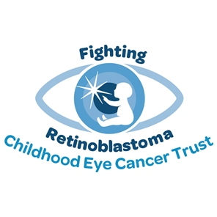
Make time for tea…
...and come along to my tea party
This September is Childhood Cancer Awareness Month
and I am holding a tea party to raise funds for the
Childhood Eye Cancer Trust so please join me.

VENUE

DATE

TIME

CONTACT



WWW.CHECT.ORG.UK
info@chect.org.uk 0207 377 5578
Registered charity no. 327493

